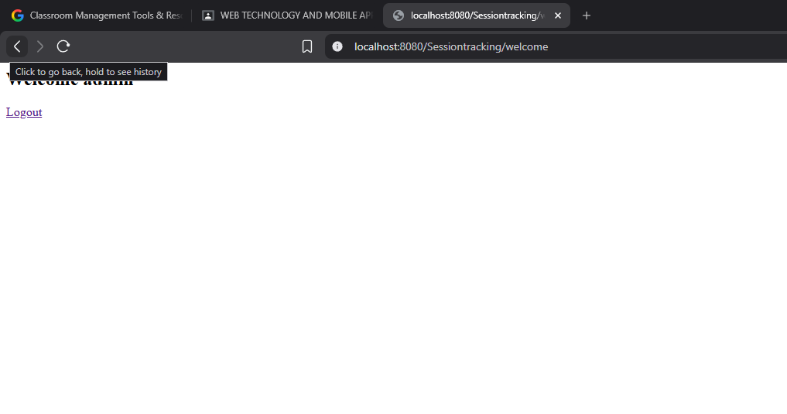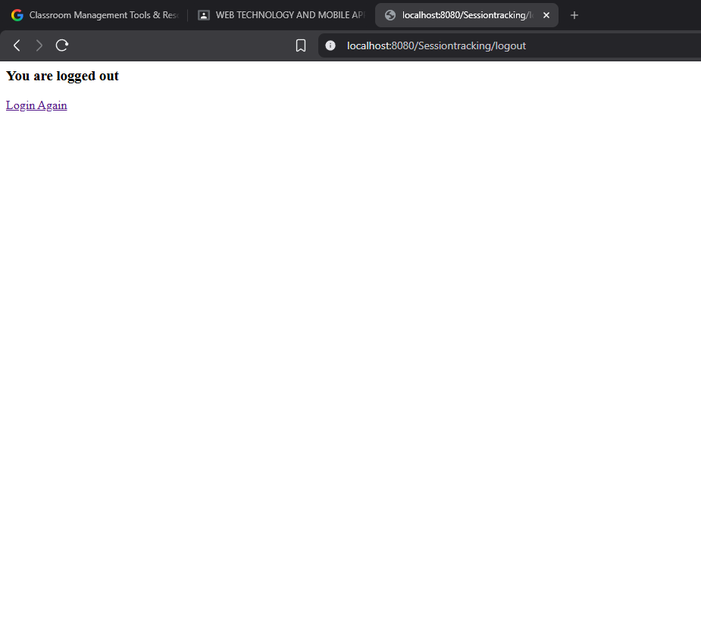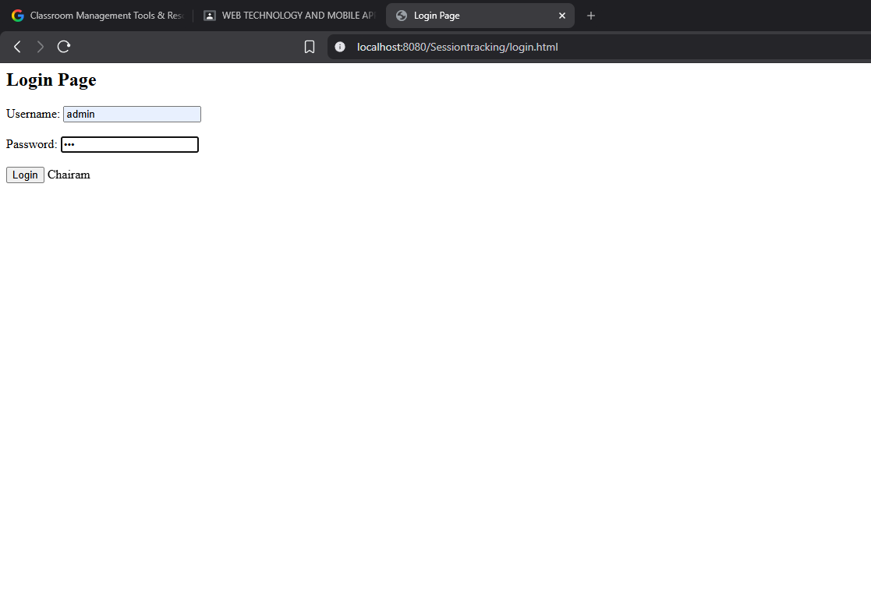
OUTPUT:

CODE:
import java.io.*;
import javax.servlet.*;
import javax.servlet.http.*;
import javax.servlet.annotation.WebServlet;

@WebServlet("/LoginServlet")

public class LoginServlet extends HttpServlet {

protected void doPost(HttpServletRequest request, HttpServletResponse response)
throws ServletException, IOException {

response.setContentType("text/html");
PrintWriter out = response.getWriter();

String username = request.getParameter("username");
String password = request.getParameter("password");

if(username.equals("admin") && password.equals("123"))
{
HttpSession session = request.getSession();
session.setAttribute("user", username);

response.sendRedirect("welcome");
}
else
{
out.println("Invalid login");
}
}
}

<html>
<head>
<title>Login Page</title>
</head>

<body>

<h2>Login Page</h2>

<form action="LoginServlet" method="post">

Username:
<input type="text" name="username"><br><br>

Password:
<input type="password" name="password"><br><br>

<input type="submit" value="Login">

Chairam

</form>

</body>
</html>

import java.io.*;
import javax.servlet.*;
import javax.servlet.http.*;
import javax.servlet.annotation.WebServlet;

@WebServlet("/welcome")

public class WelcomeServlet extends HttpServlet {

protected void doGet(HttpServletRequest request, HttpServletResponse response)
throws ServletException, IOException {

response.setContentType("text/html");
PrintWriter out = response.getWriter();

HttpSession session = request.getSession(false);

if(session!=null)
{
String user=(String)session.getAttribute("user");

out.println("<h2>Welcome "+user+"</h2>");
out.println("<a href='logout'>Logout</a>");
}
else
{
out.println("Session expired");
}
}
}

import java.io.*;
import javax.servlet.*;
import javax.servlet.http.*;
import javax.servlet.annotation.WebServlet;

@WebServlet("/logout")

public class LogoutServlet extends HttpServlet {

protected void doGet(HttpServletRequest request, HttpServletResponse response)
throws ServletException, IOException {

response.setContentType("text/html");
PrintWriter out=response.getWriter();

HttpSession session=request.getSession(false);

if(session!=null)
{
session.invalidate();
}

out.println("<h3>You are logged out</h3>");
out.println("<a href='login.html'>Login Again</a>");
}
}

